

**CSE - 316**

**LAB REPORT**

**Submitted By:**

**Name: Md. Zobayer Hasan Nayem**

**ID: 19202103274**

**Intake: 44**

**Sec: 08**

**Submitted To:**

**Nourin Khandaker**

**Dept. of CSE**

**Bangladesh University of Business and Technology**

**Experiment No: 05**

**Experiment Title**: Arduino with Potentiometer and Servo Motor

**Objective:** The Potentiometer angle should be used to spin the motor in that direction.

**Theory:** We’ll need an Arduino a servo motor and a potentiometer to get things going. Then, we will must link them so that when we adjust the potentiometer’s angle, the servo motor’s wing will follow the angle.

**Result and Discussion:** We, have include servo.h and connected the servo motor to pin 9 to use it. The map function’s angles are then set. We also connected the First pin of the potentiometer to the analog on the Arduino.

**Code:**

#include <Servo.h>

Servo myservo;

int value ;

double angle;

void setup()

{

Serial.begin(9600);

myservo.attach(9);

}

void loop()

{

value = analogRead(A0);

angle = map(value, 0, 1023, 0, 180);

Serial.println(angle);

myservo.write(angle);

delay(15);

}

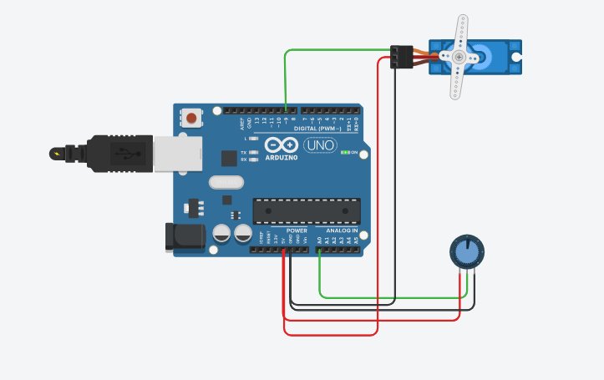**Output:**

**Conclusion:**

1. We will learn how to set up Arduino board and Potentiometer.
2. We will also learn how to connect this Arduino board and also Potentiometer
3. We will also learn how to run and displayed this potentiometer.